OH MY FOODIE!

**REPORT**

SUBMITTED FOR BTECH 2ND SEM PROJECT

at

**SAITM, Gurgaon**

**(from 7th Jan 2019 to 4th April 2019)**

SUBMITTED BY

RAJNISH KUMAR

COMPUTER SCIENCE ENGINEERING

183038



**BACHELOR OF TECHNOLOGY DEPARTMENT**

**St. Andrews Institute of Technology and Management**

Farrukhnagar, GURUGRAM

**St. Andrews Institute of Technology & Management Farrukhnagar, Gurugram**

**TO WHOM IT MAY CONCERN**

I hereby certify that “RAJNISH KUMAR” Roll No 183038 of St. Andrew’s Institute of Technology and Management, Gurgaon, has undergone **90 DAYS** from 7TH JANUARY 2019 to 4th APRIL 2019 at our organization to fulfill the requirements. He works on OH MY FOODIE! project during the training under the supervision of MS. PREETISHREE PATNAIK and project supervisior MR. PRAVEEN YADAV. During his tenure with us we found him sincere and hard working.

Wishing him a great success in the future.

Signature of the Student

Signature of the Project Guide (S) Signature of the HOD (CSE)

(Seal of Organization)

**DECLARATION**

I affirm that the project work titled **Oh My Foodie!** being submitted in partial fulfillment for the award of the degree of B.TECH is the original work carried out by me. It has not formed the part of any other project work submitted for award of any degree or diploma, either in this or any other University.

**Signature of the Candidate**

RAJNISH KUMAR

183038

I certify that the declaration made above by the candidate is true.

**Signature of the Guide**

**Mr. Praveen Yadav**

*Trainer*

St. Andrews

Institution of Technology and

Management

**TABLE OF CONTENTS**

**CHAPTER No. TITLE PAGE No.**

**List of figures and tables 5**

**1 Introduction to HTML 6**

**2 Introduction to CSS 11**

**3 Introduction to BOOTSTRAP 13**

**Brief introduction to project 14-15**

**Design of Solution 16-18**

**Methodology/ Planning of work 19-32**

**/Details of project**

**Reference 33**

**Figures and Tables**

|  |  |  |
| --- | --- | --- |
| **FIGURE** | **TITLE** | **PAGE NO.** |
| Fig1.1 | Introduction to HTML | 1­0 |
| Fig2.1  Fig2.2 | Introduction to CSS | 13 |
| Fig3.1 | Introduction to Bootstrap | 14 |
| Fig4.1 | Brief introduction to project | 16 |
| Fig5.1  Fig5.2 | Design  of  solution | 17 |
| Fig5.3  Fig5.4 | 18  19 |
| Fig6.1  Fig6.2  Fig6.3  Fig 6.4  Fig 6.5  Fig 6.6 | Methodology/ Planning of work/ Details of project | 20  22  24  26  28  33 |

**Chapter-1**

**Introduction of HTML**

* **HTML**- Hypertext Markup Language, a standardized system for tagging text files to achieve font, color, graphic, and hyperlink effects on World Wide Web pages.
* HTML is used to create electronic documents
* Each page contains a series of connections to other pages called [hyperlinks](https://www.computerhope.com/jargon/h/hyperlin.htm).
* HTML code ensures the proper formatting of text and images so that your [Internet browser](https://www.computerhope.com/jargon/b/browser.htm) may display them as they are intended to look.
* HTML elements are the building blocks of HTML pages
* HTML elements are represented by tags
* HTML tags label pieces of content such as "heading", "paragraph", "table", and so on.
* Browsers do not display the HTML tags, but use them to render the content of the page

Example:-

<!DOCTYPE html>  
<html>  
<head>  
<title>BikesBaba</title>  
</head>  
<body>

<h1>Rentalbikes</h1>  
<p>CrazyBikes</p>

</body>  
</html>

* <!DOCTYPE html> :- Document is in HTML5
* <html> :- Root element of HTML page
* <head> :- Contains meta information about the document
* <title> :- Element specifies a title for the document
* <body> :- Visible page content
* <h1> :- Large heading
* <p> :- Paragraph

## **HTML Headings**

* HTML headings are defined with the <h1> to <h6> tags.
* <h1> defines the most important heading. <h6> defines the least important heading:

### Example:-

<h1>This is heading 1</h1>  
<h2>This is heading 2</h2>  
<h3>This is heading 3</h3>

<h4>This is heading 4</h4>  
<h5>This is heading 5</h5>

<h6>This is heading 6</h6>

* **HTML Attributes**
* All HTML elements can have attributes.
* Attributes provide additional information about an element.
* Attributes are always specified in the start tag
* Attributes usually come in name/value pairs like: name="value"
* **The href attributes:-**

HTML links are defined with the <a> tag. The link address is specified in the href attribute.

Example-

<a href="bikesbaba.com">bikesbaba</a>

* **The src attribute:-**

HTML images are defined with the <img> tag.The filename of the image source is specified in the src attribute.

Example-

<img src="img_bikes.jpg">

* **The width and height attributes:-**

Images in HTML have a set of **size** attributes, which specifies the width and height of the image.

Example-

<img src="img_bike.jpg" width="200" height="300">

* **The alt attribute:-**

The alt attribute specifies an alternative text to be used, when an

image cannot be displayed. The value of the attribute can be read by

screen readers. This way, someone "listening" to the webpage, e.g. a

vision impaired person, can "hear" the element.

Example:-

<img src="img_bike.jpg" alt="boy with a bike">

* **The style attribute:-**

The style attribute is used to specify the styling of an element, like color, font, size

etc.

Example:-

<body style=”color:pink”>

* **The lang attribute:-**

The language is declared with the lang attribute.

Example:-

<!DOCTYPE html>  
<html lang="en-US">  
<body>  
</body>  
</html>

# **HTML Text Formatting**

## **HTML formatting elements**

HTML uses elements like <b> and <i> for formatting output, like

**bold** or *italic* text.

Formatting elements were designed to display special types of text:

* <b> - Bold text
* <strong> - Important text
* <i> - Italic text
* <em> - Emphasized text
* <mark> - Marked text
* <small> - Small text
* <del> - Deleted text
* <ins> - Inserted text
* <sub> - Subscript text
* <sup> - Superscript text

**Coding for signup form** :-

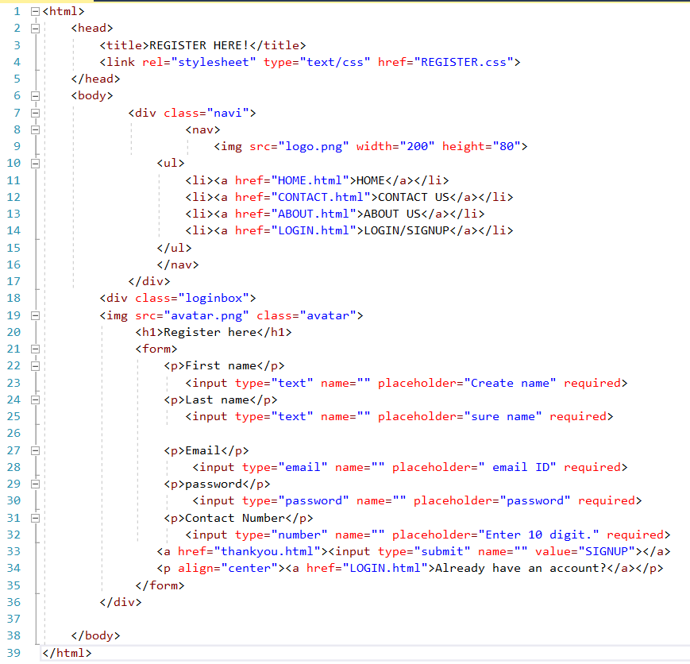

Fig:1.1

**Chapter-2**

**Introduction of CSS**

* **CSS**- Cascading Style Sheets, fondly referred to as CSS, is a simple design language intended to simplify the process of making web pages presentable.
* CSS handles the look and feel part of a web page. Using CSS, user can control the color of the text, the style of fonts, the spacing between paragraphs, how columns are sized and laid out, what background images or colors are used, layout designs ,variations in display for different devices and screen sizes as well as a variety of other effects.
* CSS is easy to learn and understand but it provides powerful control over the presentation of an HTML document.
* CSS describes how HTML elements are to be displayed on screen, paper, or in other media
* External stylesheets are stored in CSS files
* **CSS syntax:-**

A CSS rule-set consists of a selector and a declaration block.

ach declaration includes a CSS property name and a value, separated by a colon.

A CSS declaration always ends with a semicolon, and declaration blocks are surrounded by curly braces**.**

Example**:-**

p {  
    color: red;  
    text-align: center;  
}

* **CSS background:-**

CSS background properties are used to define the background effects of elements.

CSS background properties:

* background-color
* background-image
* background-repeat
* background-attachment
* background-position
* **Background color:-**

The background-color property specifies the background color of an element.

Example:-

body {

background-color: lightblue;}

* **Background image:-**

The background-image property specifies an image to use as the background of an element.

Example:-

body {

background-image: url("bike.gif");}

* **Background repeat:-**

By default, the background-image property repeats an image both horizontally and vertically.  
Some images should be repeated only horizontally or vertically, or they will look strange.

Example:- body {  
    background-image: url("gradient_bg.png");}

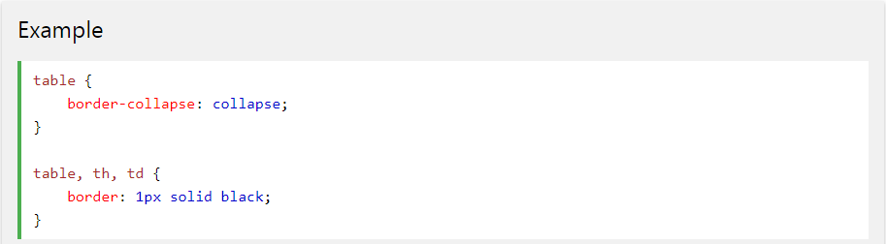

**Fig 2.1:- Screenshot of CSS**

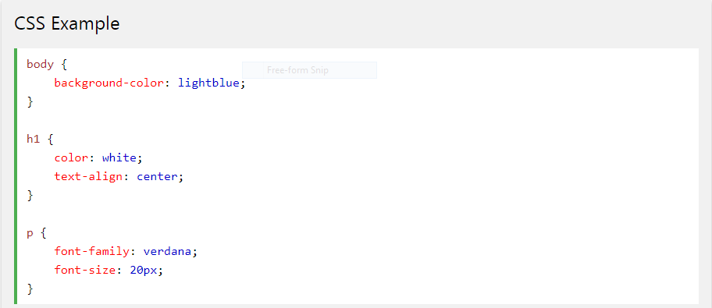

**Fig 2.2:- Screenshot of CSS**

**Chapter-3**

**Introduction of Bootstrap**

* **Bootstrap-**Bootstrap is a free and open-source front-end framework for designing websites and web applications.
* It offers HTML and CSS based design templates for typography, forms, buttons, navigation, and other interface components.
* It is concerned only with front-end development.
* Bootstrap includes user interface components, layouts and JS tools along with the framework for implementation.

Example:- Fig:3.1

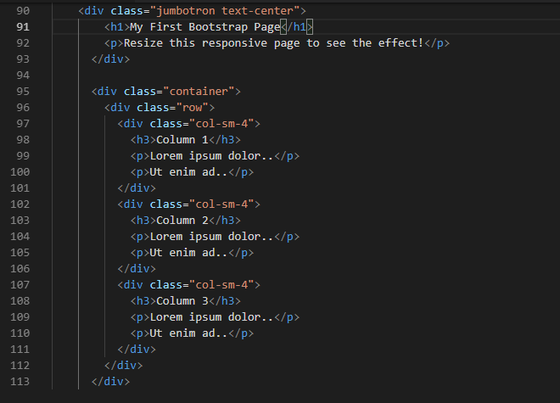

**Brief introduction to project**

**My project name**- oh my foodie!

**Description**-

* My project is based on FOOD SERVICE which provides all the facilities regarding FOOD and RESTAURANT in beautiful cities like Agra, Delhi, Lucknow,Gurugram and others.
* I have used HTML language to make this website and added some designs, which make the website more attractive and more presentable.
* I have used a little bit of CSS language to design user interface &design some internal parts of the website.
* My project contain web pages are:-

1. **HOME**
2. **ABOUT US**
3. **CONTACT US**
4. **LOGIN/SIGNUP**
5. **ORDER NOW**

**Software requirement:-**

1. **WINDOWS 7 OR HIGHER VERSION**
2. **WEB BROWSER = GOOGLE CHROME, OPERA MINI,FIREFOX**
3. **EDITOR= NOTEPAD, NOTEPAD++, VISUAL STUDIO CODE**

SCREENSHOTS OF WEBSITE:-

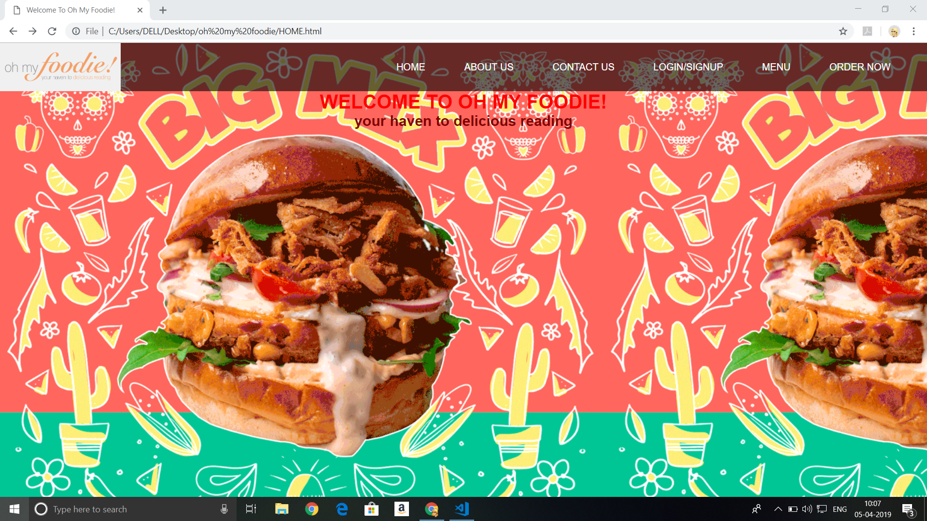

**Fig 4.1:- Screenshot of website**

**DESIGN OF SOLUTIONS**



**Fig 5.1:- Screenshot of Home page**

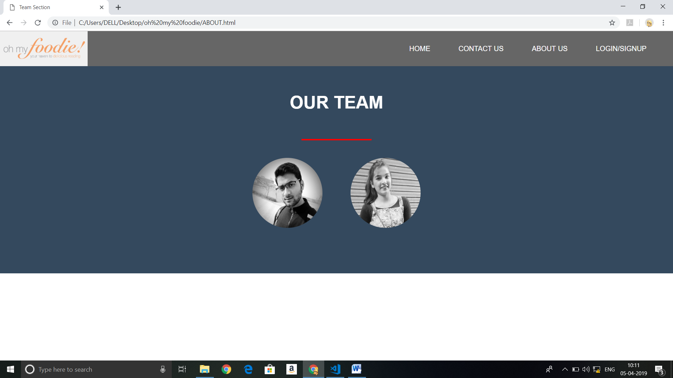

**Fig 5.2;- Screenshot of About us page**

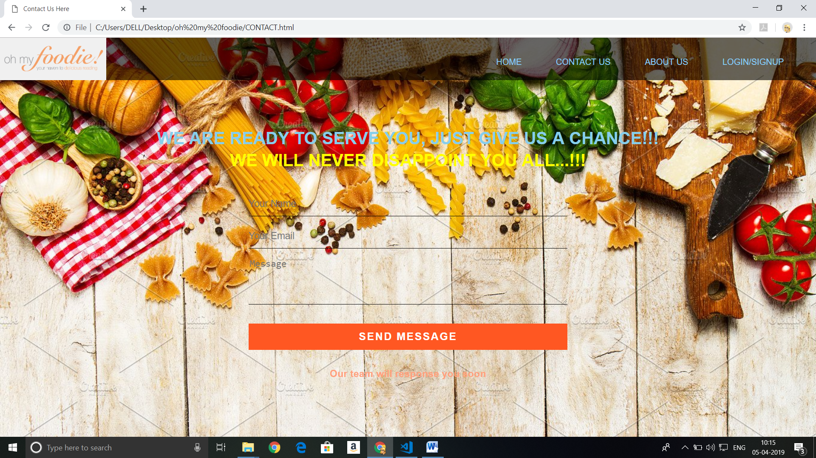

**Fig 5.3:- Screenshot of Contact us page**

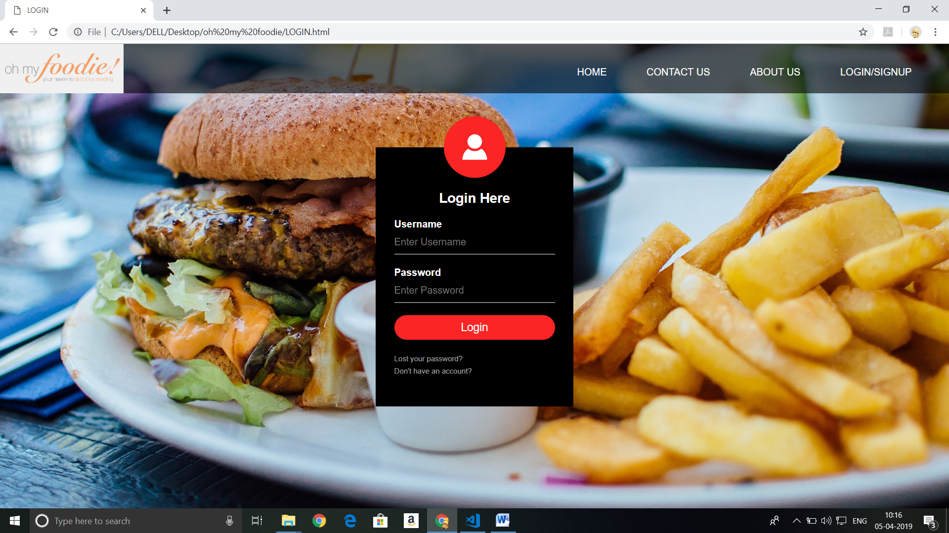

**Fig 5.4:-Screenshot of login page**

|  |
| --- |
|  |

**Fig 5.4:-Screenshot of registration page**

**Methodology/ Planning of work/ Details of project**

**Home page coding**:-

<html>

<head>

<title>oh my foodie!</title>

<link rel="stylesheet" type="text/css" href="HOME.css">

</head>

<body>

<div class="navi">

<nav>

<imgsrc="logo.png" width="200" height="80">

<ul>

<li><a href="HOME.html">HOME</a></li>

<li><a href="CONTACT.html">CONTACT US</a></li>

<li><a href="ABOUT.html">ABOUT US</a></li>

<li><a href="LOGIN.html">LOGIN/SIGNUP</a></li>

</ul>

</nav>

</div>

</body>

</html>

**Output:-**



**Fig 6.1:- Screenshot of Home page**

**About us coding**:-

<!DOCTYPE html>

<html>

<head>

<meta charset="utf-8">

<title>Team Section</title>

<link rel="stylesheet" type="text/css" href="ABOUT.css">

</head>

<body>

<div class="navi">

<nav>

<imgsrc="logo.png" width="200" height="80">

<ul>

<li><a href="HOME.html">HOME</a></li>

<li><a href="CONTACT.html">CONTACT US</a></li>

<li><a href="ABOUT.html">ABOUT US</a></li>

<li><a href="LOGIN.html">LOGIN/SIGNUP</a></li>

</ul>

</nav>

</div>

<div class="team-section">

<h1>Our Team</h1>

<span class="border"></span>

<div class="ps">

<a href="#p1"><imgsrc="rajnish.jpg" alt="" height="180px" width="150px"></a>

<a href="#p2"><imgsrc="simran.jpg" alt="" height="180px" width="150px"></a>

</div>

<div class="section" id="p1">

<span class="name">RAJNISH KUMAR</span>

<span class="border"></span>

<p>

Coder and web site desiner

</p>

<p>

### UIDesigner

</p>

</div>

<div class="section" id="p2">

<span class="name">SIMRAN SALUJA</span>

<span class="border"></span>

<p>

Data collector and research

</p>

</div>

</div>

</div>

</body>

</html>

**Output:-**

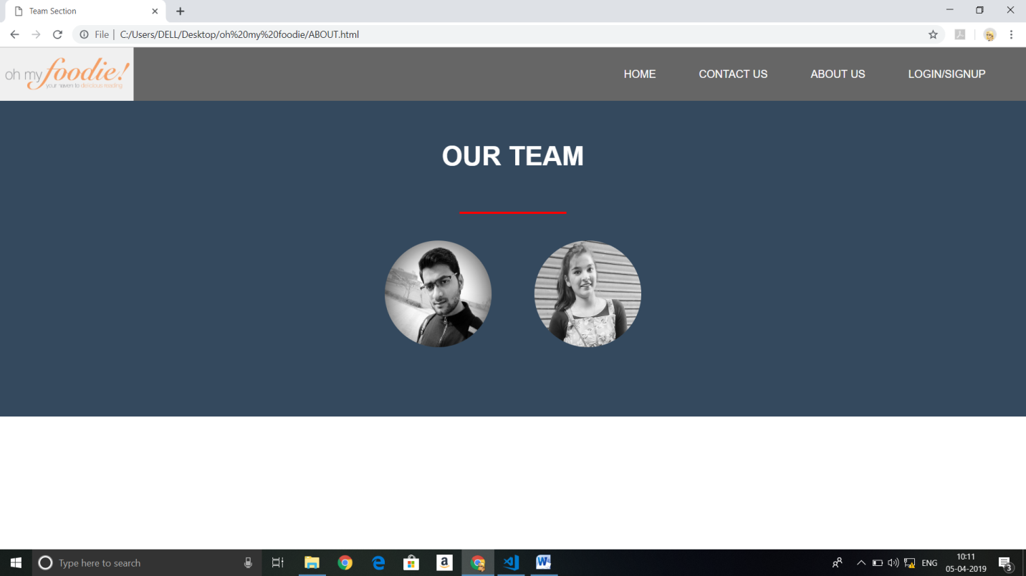

**Fig 6.2:- Screenshot of About us page**

**Contact us:-**

<html>

<head>

<title>Contact Us Here!</title>

<link rel="stylesheet" type="text/css" href="CONTACT.css">

</head>

<body>

<div class="navi">

<nav>

<imgsrc="logo.png" width="200" height="80">

<ul>

<li><a href="HOME.html">HOME</a></li>

<li><a href="CONTACT.html">CONTACT US</a></li>

<li><a href="ABOUT.html">ABOUT US</a></li>

<li><a href="LOGIN.html">LOGIN/SIGNUP</a></li>

</ul>

</nav>

</div>

<div class="contact-title">

<h1>WE ARE READY TO SERVE YOU, JUST GIVE US A CHANCE!!!</h1>

<h1style="color:yellow">We will never disappoint you all...!!!</h1>

</div>

<div class="contact-form">

<form id="contact-form" method="POST" action="">

<input name="name" type="text" class="form-control" placeholder="Your Name" required><br>

<input name="email" type="email" class="form-control" placeholder="Your Email" required><br>

<textarea name="message" class="form-control" placeholder="Message" rows="4" required></textarea><br>

<input type="submit" class="form-control submit" value="SEND MESSAGE">

</form>

</div>

</body>

</html>

**Output:-**

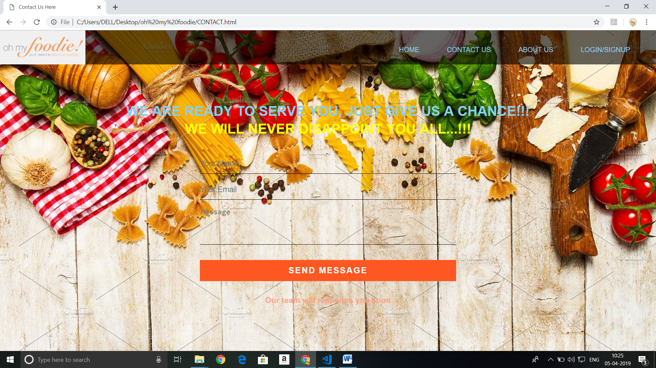

**Fig 6.3:- Screenshot of Contact Us page**

**Log in page coding:-**

<html>

<head>

<title>LOGIN</title>

<link rel="stylesheet" type="text/css" href="LOGIN.css">

</head>

<body>

<div class="navi">

<nav>

<imgsrc="logo.png" width="200" height="80">

<ul>

<li><a href="HOME.html">HOME</a></li>

<li><a href="CONTACT.html">CONTACT US</a></li>

<li><a href="ABOUT.html">ABOUT US</a></li>

<li><a href="LOGIN.html">LOGIN/SIGNUP</a></li>

</ul>

</nav>

</div>

<div class="loginbox">

<imgsrc="avatar.png" class="avatar">

<h1>Login Here</h1>

<form>

<p>Username</p>

<input type="text" name="" placeholder="Enter Username">

<p>Password</p>

<input type="password" name="" placeholder="Enter Password">

<input type="submit" name="" value="Login">

<a href="#">Lost your password?</a><br>

<a href="REGISTER.html">Don't have an account?</a>

</form>

</div>

</body>

</html>

**Output:-**

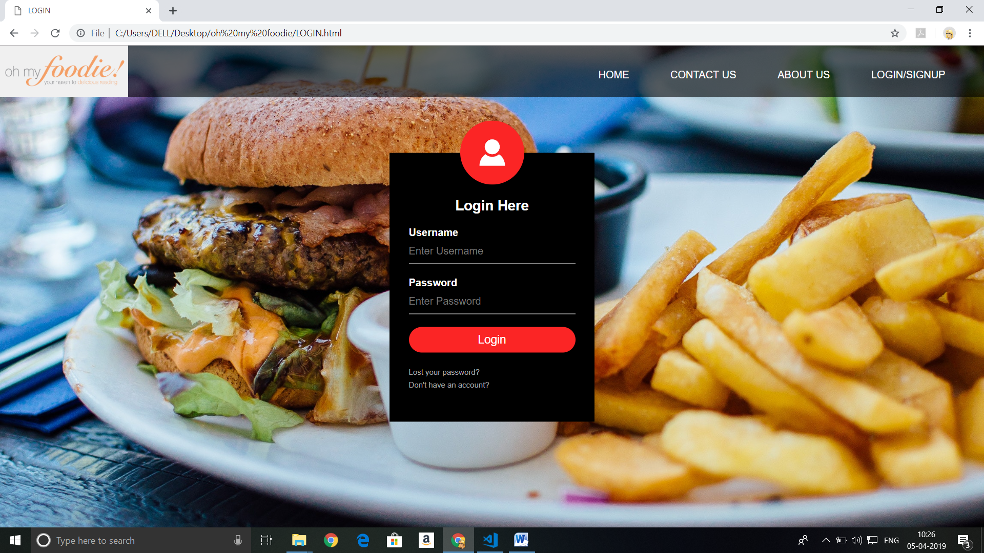

**Fig 6.4:- Screenshot of Login page**

*

**Registration page coding:-**

<html>

<head>

<title>REGISTER HERE!</title>

<link rel="stylesheet" type="text/css" href="REGISTER.css">

</head>

<body>

<div class="navi">

<nav>

<img src="logo.png" width="200" height="80">

<ul>

<li><a href="HOME.html">HOME</a></li>

<li><a href="CONTACT.html">CONTACT US</a></li>

<li><a href="ABOUT.html">ABOUT US</a></li>

<li><a href="LOGIN.html">LOGIN/SIGNUP</a></li>

</ul>

</nav>

</div>

<div class="loginbox">

<img src="avatar.png" class="avatar">

<h1>Register here</h1>

<form>

<p>First name</p>

<input type="text" name="" placeholder="Create name" required>

<p>Last name</p>

<input type="text" name="" placeholder="sure name" required>

<p>Email</p>

<input type="email" name="" placeholder=" email ID" required>

<p>password</p>

<input type="password" name="" placeholder="password" required>

<p>Contact Number</p>

<input type="number" name="" placeholder="Enter 10 digit." required>

<a href="thankyou.html"><input type="submit" name="" value="SIGNUP"></a>

<p align="center"><a href="LOGIN.html">Already have an account?</a></p>

</form>

</div>

</body>

</html>

**Output:-**

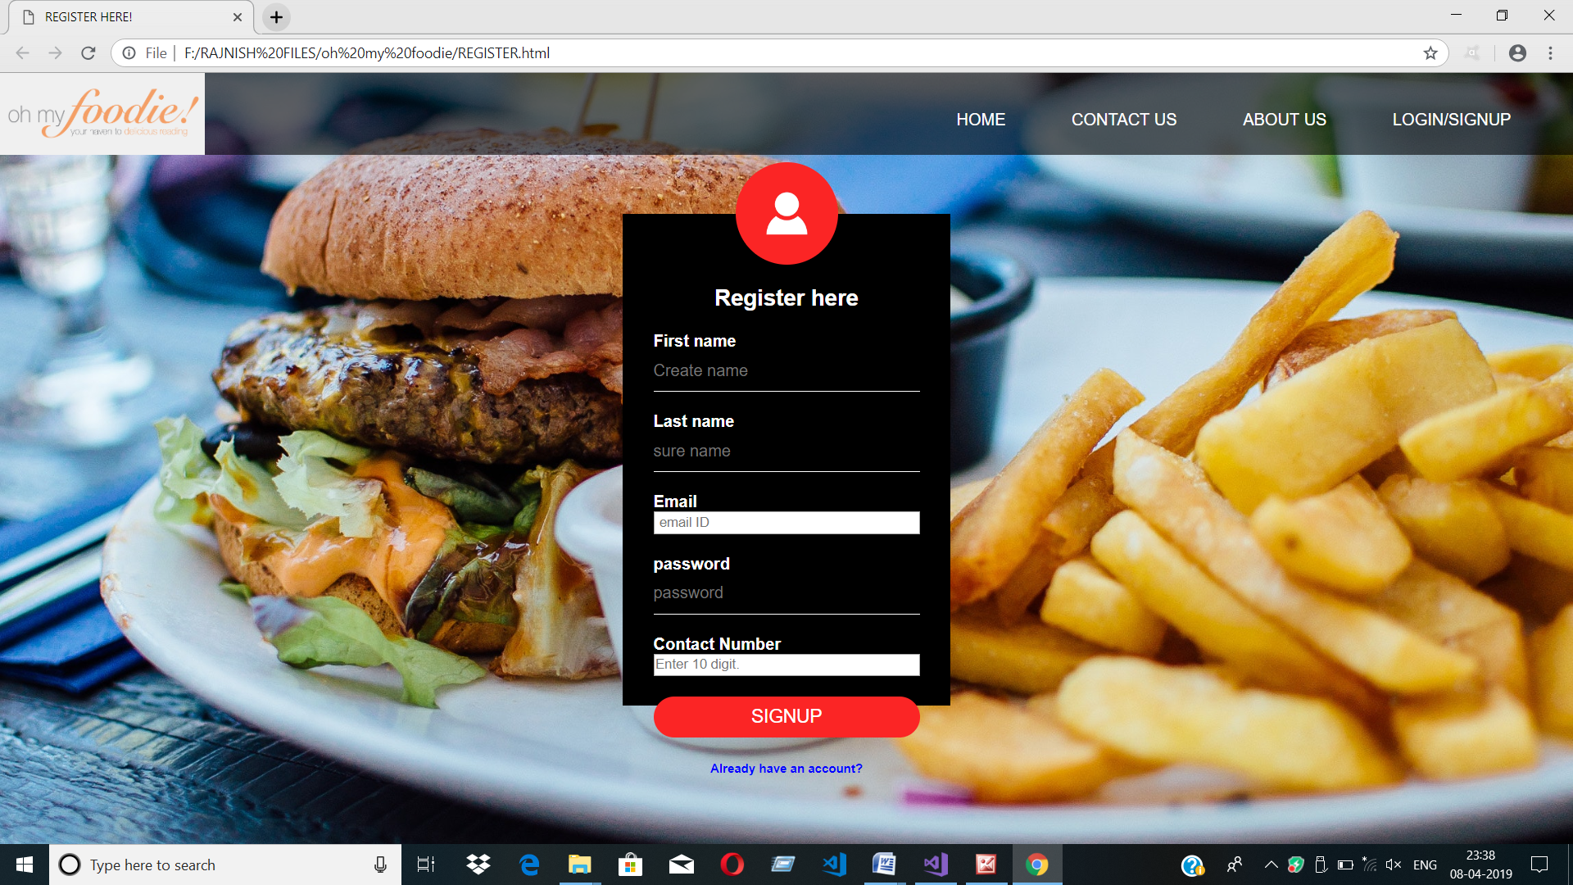

**Fig 6.5:- Screenshot of Registration page**

**Order Now Page Coding:-**

<!DOCTYPE html>

<html>

<head>

<title>ORDER NOW!</title>

<meta name="viewport" content="width=device-width, initial-scale=1">

<link rel="stylesheet" href="ORDER NOW.css">

<style>

body {

font-family: Arial;

font-size: 17px;

padding: 8px;

}

**\*** {

box-sizing: border-box;

}

**.row** {

display: -ms-flexbox; /* IE10 */

display: flex;

-ms-flex-wrap: wrap; /* IE10 */

flex-wrap: wrap;

margin: 0 -16px;

}

**.col-25** {

-ms-flex: 25%; /* IE10 */

flex: 25%;

}

**.col-50** {

-ms-flex: 50%; /* IE10 */

flex: 50%;

}

**.col-75** {

-ms-flex: 75%; /* IE10 */

flex: 75%;

}

**.col-25**,

**.col-50**,

**.col-75** {

padding: 0 16px;

}

**.container** {

background-color: #f2f2f2;

padding: 5px 20px 15px 20px;

border: 1px solid lightgrey;

border-radius: 3px;

}

input[**type**=text] {

width: 100%;

margin-bottom: 20px;

padding: 12px;

border: 1px solid #ccc;

border-radius: 3px;

}

label {

margin-bottom: 10px;

display: block;

}

**.icon-container** {

margin-bottom: 20px;

padding: 7px 0;

font-size: 24px;

}

**.btn** {

background-color: #4CAF50;

color: white;

padding: 12px;

margin: 10px 0;

border: none;

width: 100%;

border-radius: 3px;

cursor: pointer;

font-size: 17px;

}

**.btn:hover** {

background-color: #45a049;

}

a {

color: #2196F3;

}

hr {

border: 1px solid lightgrey;

}

span**.price** {

float: right;

color: grey;

}

@media (max-width: 800px) {

**.row** {

flex-direction: column-reverse;

}

**.col-25** {

margin-bottom: 20px;

}

}

</style>

**0**

</head>

<body bgcolor="orange">

<div class="navi">

<nav>

<img src="logo.png" width="200" height="80">

<ul>

<li><a href="HOME.html">HOME</a></li>

<li><a href="CONTACT.html">CONTACT US</a></li>

<li><a href="ABOUT.html">ABOUT US</a></li>

<li><a href="LOGIN.html">LOGIN/SIGNUP</a></li>

</ul>

</nav>

</div>

<h1 align="center"><u>Responsive Checkout Form</u></h1>

<div class="row">

<div class="col-75">

<div class="container">

<form action="/action_page.php">

<div class="row">

<div class="col-50">

<h2>Billing Address</h2>

<label for="fname"><i class="fa fa-user"></i> Full Name</label>

<input type="text" id="fname" name="firstname" placeholder="Enter your full name" required>

<label for="Phone"><i class="fa fa-user"></i>Phone Number</label>

<input type="text" id="phone" name="phnno" placeholder="Enter your phone number" required>

<label for="email"><i class="fa fa-envelope"></i> Email</label>

<input type="text" id="email" name="email" placeholder="email@example.com" required>

<label for="adr"><i class="fa fa-address-card-o"></i> Address</label>

<input type="text" id="adr" name="address" placeholder="Enter Your Address" required>

<label for="city"><i class="fa fa-institution"></i> City</label>

<input type="text" id="city" name="city" placeholder="New Delhi" required>

<div class="row">

<div class="col-50">

<label for="state">State</label>

<input type="text" id="state" name="state" placeholder="Delhi" required>

</div>

<div class="col-50">

<label for="zip">Zip</label>

<input type="text" id="zip" name="zip" placeholder="112233" maxlength="6" required>

</div>

</div>

</div>

<div class="col-50">

<form>

<h2>Payment</h2><br>

<input type="radio" name="method" value="Cash On Delivery" >Cash on delievery<br>

<input type="radio" name="method" value="Card accepted" >Card acccepted<br>

</form>

div class="icon-container">

<i class="fa fa-cc-visa" style="color:navy;"></i>

<i class="fa fa-cc-amex" style="color:blue;"></i>

<i class="fa fa-cc-mastercard" style="color:red;"></i>

<i class="fa fa-cc-discover" style="color:orange;"></i>

</div>

<label for="cname">Name on Card</label>

<input type="text" id="cname" name="cardname" placeholder="Munna Michael">

<label for="ccnum">Credit card number</label>

<input type="text" id="ccnum" name="cardnumber" placeholder="1111-2222-3333-4444" maxlength="16">

<label for="expmonth">Exp Month</label>

<input type="text" id="expmonth" name="expmonth" placeholder="September">

<div class="row">

<div class="col-50">

<label for="expyear">Exp Year</label>

<input type="text" id="expyear" name="expyear" placeholder="2018" maxlength="4">

</div>

<div class="col-50">

<label for="cvv">CVV</label>

<input type="password" id="cvv" name="cvv" placeholder="352" maxlength="3">

</div>

</div>

</div>

</div>

<label>

<input type="checkbox" checked="checked" name="sameadr" required> Shipping address same as billing<br>

</label>

<p><b><u>T&C*</u></b></p>

<ul>

<li>Order will not be cancelled after checkout</li>

<li>Free delivery within 3k.m. after that Rs.10/k.m. will be charged</li>

</ul>

<input type="submit" value="PROCEED TO CHECKOUT" class="btn" style="color:blue;background-color: orange">

</form>

</div>

</div>

</div>

</body>

</html>

**Output:-**

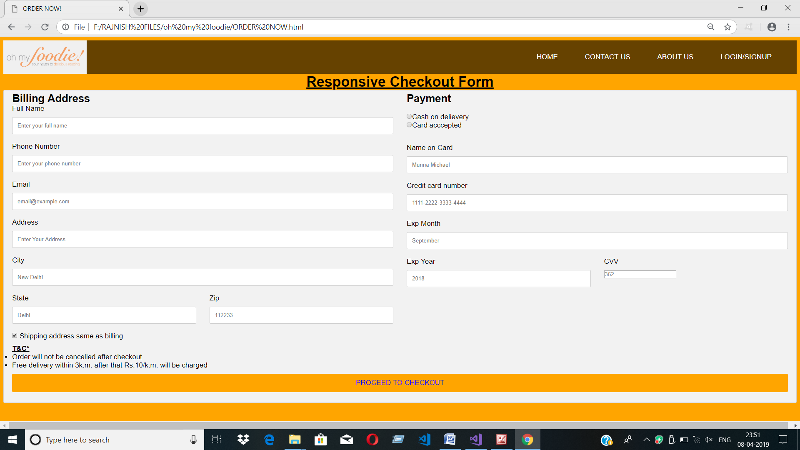

**Fig 6.6:- Screenshot of Order Now page**

**Reference**

* [**www.w3schools.com**](http://www.w3schools.com)
* [**www.getbootstrap.com**](http://www.getbootstrap.com)
* [**www.youtube.com**](http://www.youtube.com)